DEPARTMENT OF COMPUTER STUDIES

(Applications Development and Emerging Technologies)

PRE-SUMMATIVE ASSESSMENT
4

PHP PRE DEFINED FUNCTIONS

Student Name / Group Name:
Members (if Group): | Name Role
Section:
Professor:

- PROGRAM OUTCOME/S (PO) ADDRESSED BY THE LABORATORY EXERCISE
- Design, implement and evaluate computer-based systems or applications to meet desired needs and requirements.
- COURSE LEARNING OUTCOME/S (CLO) ADDRESSED BY THE LABORATORY EXERCISE
- Understand and apply best practices and standards in the development of website.
- INTENDED LEARNING OUTCOME/S (ILO) OF THE LABORATORY EXERCISE
At the end of this exercise, students must be able to:
- To know how to include separate PHP code in the main page for code enhancement.
- To be familiar with the use of common predefined function such as define, include, and require.
- To use different available mathematical function for manipulating numbers.
- BACKGROUND INFORMATION
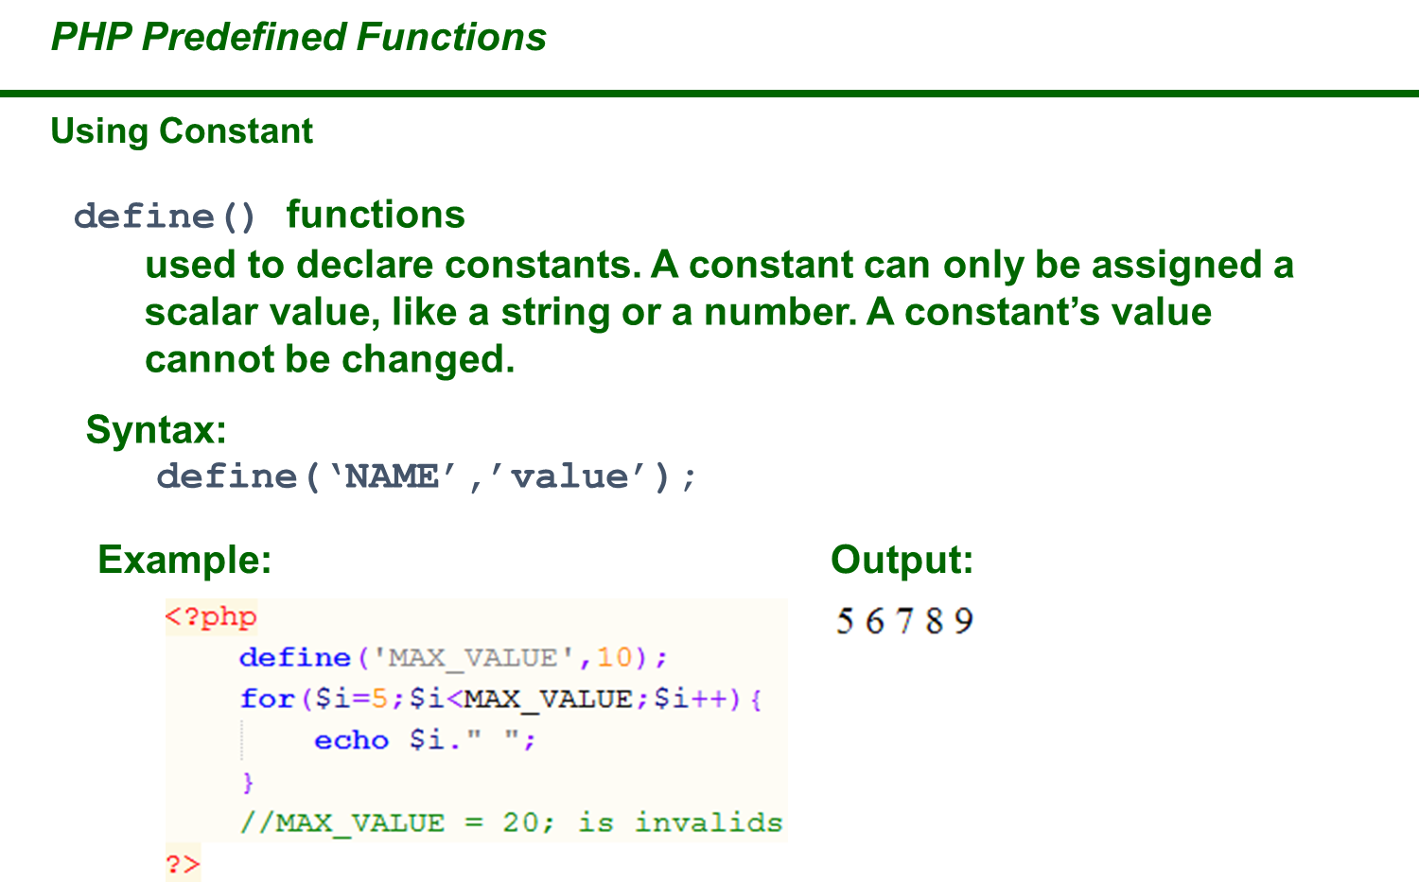
PHP Constants
Constants are like variables except that once they are defined they cannot be changed or undefined.
A constant is an identifier (name) for a simple value. The value cannot be changed during the script.
A valid constant name starts with a letter or underscore (no $ sign before the constant name).
Note: Unlike variables, constants are automatically global across the entire script.
Create a PHP Constant
To create a constant, use the define() function.
Syntax
define(name, value, case-insensitive)
Parameters:
- name: Specifies the name of the constant
- value: Specifies the value of the constant
- case-insensitive: Specifies whether the constant name should be case-insensitive. Default is false
Example
Create a constant with a case-sensitive name:
<?php
define("GREETING", "Welcome to PHP Programming!");
echo GREETING;
?>
PHP Include Files
The include (or require) statement takes all the text/code/markup that exists in the specified file and copies it into the file that uses the include statement.
Including files is very useful when you want to include the same PHP, HTML, or text on multiple pages of a website.

PHP include and require Statements
It is possible to insert the content of one PHP file into another PHP file (before the server executes it), with the include or require statement.
The include and require statements are identical, except upon failure:
- require will produce a fatal error (E_COMPILE_ERROR) and stop the script
- include will only produce a warning (E_WARNING) and the script will continue
So, if you want the execution to go on and show users the output, even if the include file is missing, use the include statement. Otherwise, in case of FrameWork, CMS, or a complex PHP application coding, always use the require statement to include a key file to the flow of execution. This will help avoid compromising your application's security and integrity, just in-case one key file is accidentally missing.
Including files saves a lot of work. This means that you can create a standard header, footer, or menu file for all your web pages. Then, when the header needs to be updated, you can only update the header include file.
Syntax
include 'filename';
or
require 'filename';

PHP include Examples
Example 1
Assume we have a standard footer file called "footer.php", that looks like this:
<?php
echo "<p>Copyright &copy; 1999-" . date("Y") . " W3Schools.com</p>";
?>
To include the footer file in a page, use the include statement:
Example
<html>
<body>
<h1>Welcome to my home page!</h1>
<p>Some text.</p>
<p>Some more text.</p>
<?php include 'footer.php';?>
</body>
</html>
Example 2
Assume we have a standard menu file called "menu.php":
<?php
echo '<a href="/default.asp">Home</a> -
<a href="/html/default.asp">HTML Tutorial</a> -
<a href="/css/default.asp">CSS Tutorial</a> -
<a href="/js/default.asp">JavaScript Tutorial</a> -
<a href="default.asp">PHP Tutorial</a>';
?>
All pages in the Web site should use this menu file. Here is how it can be done (we are using a <div> element so that the menu easily can be styled with CSS later):
Example
<html>
<body>
<div class="menu">
<?php include 'menu.php';?>
</div>
<h1>Welcome to my home page!</h1>
<p>Some text.</p>
<p>Some more text.</p>
</body>
</html>
Example 3
Assume we have a file called "vars.php", with some variables defined:
<?php
$color='red';
$car='BMW';
?>
Then, if we include the "vars.php" file, the variables can be used in the calling file:
Example
<html>
<body>
<h1>Welcome to my home page!</h1>
<?php include 'vars.php';
echo "I have a $color $car.";
?>
</body>
</html>
PHP include vs. require
The require statement is also used to include a file into the PHP code.
However, there is one big difference between include and require; when a file is included with the include statement and PHP cannot find it, the script will continue to execute:
Example
<html>
<body>
<h1>Welcome to my home page!</h1>
<?php include 'noFileExists.php';
echo "I have a $color $car.";
?>
</body>
</html>
If we do the same example using the require statement, the echo statement will not be executed because the script execution dies after the require statement returned a fatal error:
Example
<html>
<body>
<h1>Welcome to my home page!</h1>
<?php require 'noFileExists.php';
echo "I have a $color $car.";
?>
</body>
</html>
PHP String Functions
In this chapter we will look at some commonly used functions to manipulate strings.
strlen() - Return the Length of a String
The PHP strlen() function returns the length of a string.
Example
Return the length of the string "Hello world!":
<?php
echo strlen("Hello world!"); // outputs 12
?>
str_word_count() - Count Words in a String
The PHP str_word_count() function counts the number of words in a string.
Example
Count the number of word in the string "Hello world!":
<?php
echo str_word_count("Hello world!"); // outputs 2
?>
strrev() - Reverse a String
The PHP strrev() function reverses a string.
Example
Reverse the string "Hello world!":
<?php
echo strrev("Hello world!"); // outputs !dlrow olleH
?>
strpos() - Search For a Text Within a String
The PHP strpos() function searches for a specific text within a string. If a match is found, the function returns the character position of the first match. If no match is found, it will return FALSE.
Example
Search for the text "world" in the string "Hello world!":
<?php
echo strpos("Hello world!", "world"); // outputs 6
?>
Tip: The first character position in a string is 0 (not 1).
str_replace() - Replace Text Within a String
The PHP str_replace() function replaces some characters with some other characters in a string.
Example
Replace the text "world" with "Dolly":
<?php
echo str_replace("world", "Dolly", "Hello world!"); // outputs Hello Dolly!
?>

- GRADING SYSTEM / RUBRIC (please see separate sheet)
- LABORATORY ACTIVITY

- Create 5 different short story webpages and Convert your stories into a web based form, use include() and require() functions to connect all pages integrate with HTML and CSS (Put images on the stories). See the format below:


- Creation of String Function in PHP, create an array with 20 different names and get the following:
  - Number of characters of each name include spaces
  - Change the first character of each name into upper case
  - Replace all vowels with @ symbol
  - Check the position of letter a
  - Change the name into reverse formate
Please see the sample below

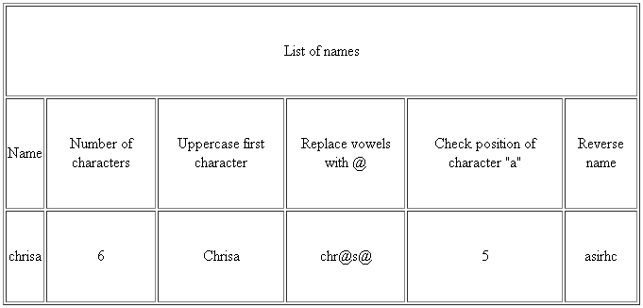

Snip and paste your source codes here. Snip it directly from the IDE so that colors of the codes are preserved for readability. Include additional pages if necessary.

VII. QUESTION AND ANSWER

- What is Constant in PHP
- What is the difference between include and require? Explain
- What are the different string functions? Explain each
VIII. REFERENCES

- https://www.w3schools.com/css/
- https://www.w3schools.com/html/
- https://www.w3schools.com/php/php_variables.asp
- https://www.w3schools.com/php/php_constants.asp
- https://www.w3schools.com/php/php_includes.asp
- https://www.w3schools.com/php/php_string.asp
Note: The following rubrics/metrics will be used to grade students’ output.

Program (100 pts.) | (Excellent) | (Good) | (Fair) | (Poor)
Program execution (20pts) | Program executes correctly with no syntax or runtime errors (18-20pts) | Program executes with less than 3 errors (15-17pts) | Program executes with more than 3 errors (12-14pts) | Program does not execute (10-11pts)
Correct output  (20pts) | Program displays correct output with no errors (18-20pts) | Output has minor errors (15-17pts) | Output has multiple errors (12-14pts) | Output is incorrect (10-11pts)
Design of output  (10pts) | Program displays more than expected (10pts) | Program displays minimally expected output (8-9pts) | Program does not display the required output (6-7pts) | Output is poorly designed (5pts)
Design of logic  (20pts) | Program is logically well designed (18-20pts) | Program has slight logic errors that do no significantly affect the results (15-17pts) | Program has significant logic errors (3-5pts) | Program is incorrect (10-11pts)
Standards  (20pts) | Program code is stylistically well designed (18-20pts) | Few inappropriate design choices (i.e. poor variable names, improper indentation) (15-17pts) | Several inappropriate design choices (i.e. poor variable names, improper indentation) (12-14pts) | Program is poorly written (10-11pts)
Delivery  (10pts) | The program was delivered on time. (10pts) | The program was delivered a day after the deadline. (8-9pts) | The program was delivered two days after the deadline. (6-7pts) | The program was delivered more than two days after the deadline. (5pts)

